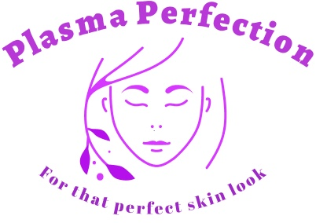
Plasma Skin Tightening
Plasma Fibroblast non-surgical rejuvenating skin treatment.
Plasma is an innovative treatment that delivers the same results as surgery, but without suturing or scalpels. The area to be treated is changed into vapor (sublimated) using the plasma beam without hurting the muscle or deep skin.
BENEFITS:
- Treatment is essentially painless
- Rejuvenation without surgery
- No need to cut skin or gets stitches
- No need for anaesthetic injections
- Immediate and outstanding results
- Reduced downtime and side-effects

WHAT AREAS CAN PLASMA TREAT?
- Blepharoplasty without surgery – tightens skin around lower and upper eyelids
- Skin lesions like skin tags, moles, warts, fibromas, xanthelasma, and papillomas, seborrheic keratosis
- Undesired face wrinkles – crow’s feet, frown lines, necklines, smoker’s lines, etc.
- Pigmentation of skin, age spots on hands or face, melasma, sun spots, freckles, chloasma
- Scars such as acne scars, stretch marks, or post-surgery scars

Plasma treatment is comprised of several plasma arc dots positioned closely around one another. Treatment can be performed on most body and facial areas. The procedure generally lasts as long as an hour. Outcomes are immediate, but the most optimal looks are noticeable after 8 to 12 weeks. Up to 3 treatments every 12 weeks is suggested for results that resemble surgical work.
Work principle:
Much like CO2 (carbon dioxide) laser beauty equipment, Plasma utilizes micro-plasma technology at high frequencies and low temperatures. It has sufficient microcomputer chip and capacity conversion regulation. When freckled skin is touched by the needle, it creates a small flame.
The microvascular will heal up fast without any bleeding. Afterward, carbon scabs will form that shield wounded skin from infection. The scab will come off on its own after seven days or so and won’t leave a scar behind.

Function:
- Adipose
- Prominent scars
- Flat wart
- Skin tag
- Age spots
- Tattoo removal
- Corns and small warts
- Wrinkle removal
- Skin Lifting

Plasma Skin Tightening
- Treatment that’s essentially pain-free
- Downtime is minimal
- Non-surgical blepharoplasty
- Non-surgical brow lift
- Immediate and astonishing results

Zap! Plasma brow lift, skin tightening, and non-surgical eye lift blepharoplasty is an innovative new treatment.
This state-of-the-art technology uses plasma – created through ionization of atmospheric gasses – to trigger immediate tightening and contraction of skin fibers. This technology doesn’t use lasers or scalpels to take away a surplus of skin. As such, all risks that come with conventional intervention are bypassed. The treatment is conducted without burning or cutting and won’t eliminate fat or skin.
The treatment is conducted through minute spots via the Plasma equipment at specific distances from each other to trigger immediate tightening and contraction of skin fibers. All of these spots sublimate the superficial corneocytes without impacting the basal laminae and without stimulating bleeding. Further, it won’t result in damage to nearby tissue.
On average, sessions last as long as a hour, but patients need to attend the appointment half hour before the procedure to get a topical numbing cream placed on the treatment area. After three to five days, the crustations will go away on their own. Many people notice results right after the initial treatment, but some might need extra treatments. This comes down to what you’re anticipating. Patients might endure some mild discomfort and swelling for a few days at the most. The skin type of each guest is different, and the healing process may lead to mild discoloration of the skin. Residual crustations will fall off within the week, but liquid foundation can be used to cover it up. During your consultation, we will talk about your treatment and what to anticipate.

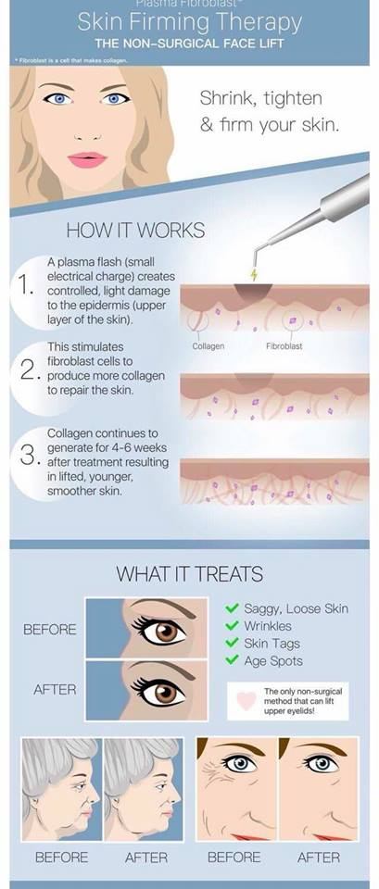
FAQs for Plasma Skin Tightening
What does the Zap! plasma skin tightening process entail?
This innovative process uses plasma – created via ionization of atmospheric gasses – to trigger immediate tightening and contraction of skin fibers. This technology doesn’t use lasers or scalpels to take excess skin away, and as such, bypasses dangers that come with conventional intervention. The treatment is conducted without burning or cutting, nor will any surplus of fat or skin be removed.
Your consultation
It is mandatory for each potential patient to have an in-person meeting before booking an appointment for this procedure. This consultation will involve address your concerns, assess your face, and/or talk about the variety of treatments. You aren’t obligated to commit to anything, nor will you be pressured into undergoing any treatment.
Zap! plasma blepharoplasty or brow lift post-treatment
Right after the procedure, the area treated will be slightly swollen and very red. Moderate discoloration/crustations will be apparent on the areas treated. Over the next few hours, swelling might become more severe for as long as 72 hours. The discoloration/crustations will go away on their own between 5 and 7 days afterward. Liquid foundation or makeup can be applied the day after. You’ll be given a cream to ease the discomfort and swelling. Post-treatment results are immediate and get better over a 2 to 4-week span.
How do I optimize the impact of the Zap! plasma treatment?
While the discoloration/crustations might flake away right after treatment, we suggest leaving them alone for at least 5 to 7 days. To optimize the impact of the Plasma non-surgical blepharoplasty and brow lift, we advise you to adhere to these tips:
- Bypass putting on any makeup until the next day.
- Bypass all direct heat sources, like the sun, saunas, UV radiation, etc., for 28 days.
- Try not to rub the discoloration/crustations away for the first 5 to 7 days.
- On the areas treated, apply anti-histamine serum/eye cream a few times per day.

Are there any side effects?
Right after the procedure, the areas treated will be slightly swollen and very red. Moderate discoloration/crustations will be apparent in the areas treated. Over the next few hours, severe swelling may occur, which might last as long as 72 hours. The discoloration/crustations should go away by the end of the week. Liquid foundation or cosmetics can be put on the next day. You’ll be given medication to ease the discomfort and swelling.
When will I begin to see the effects after my initial treatment?
Immediate results are apparent after treatment and slowly get better over the next 14 days.
How long can I expect the treatment impact to last?
The treatment triggers immediate shortening and contraction of skin fibers, which are active over the next 14 days. The treatment impact is contingent on your age and the amount of treatments you undergo, but on average, the results last for three years. As you get older, your skin will keep getting lighter and become looser. We suggest ongoing treatments one year after the first procedure
How many treatments are necessary?
The amount of treatments needed will differ based on the laxity severity, the intended correction degree, and the patient’s physiological reaction to the treatment. Our patients have noticed strong results in comparison to other practitioners’ methods, which only provide the bare minimum of treatment protocols. Many of our patients notice improvements right away and for another 6 to 8-week span afterward. You might want to have more treatments for optimal results. If you want a secondary treatment, it should take place in 8 to 12 weekly intervals.
Am I an ideal candidate for Zap! plasma treatment?
If you are not happy with loose skin in your lower and upper eyelids, or if your eyebrows feel heavy and you want a virtually painless, non-surgical answer to a brow lift or skin tightening, then the Plasma non-surgical eye lift blepharoplasty and plasma brow lift might be just what you need.
Treatment process
Plasma stimulates sublimation, a process that coverts a solid straight into a gas. As such, results are immediate. Heat is not sent to nearby tissues, so normal skin won’t suffer any harm. The device utilizes plasma, and as such, there aren’t any electric currents that can lead to problems. The treatment leads to tissue tightening and retraction, providing optimal outcomes.
How safe is it, and is any pain involved?
A half-hour prior to your treatment a local anaesthetic cream is applied to reduce any discomfort. The process is essentially pain-free afterward. The treatment might get hot in areas, and there might be a burning or tingling feeling afterward.
Plasma technology has been utilized all over the world for many years with no reported negative reactions.
Side-effects
Post-Plasma treatment, small black/brown spots might show up, or there could be a look that resembles a burn. Swelling is typical mostly around the eyes and usually lasts several days. The area will be warm and red right away after the process and can be very tender for several days as well. Patients might endure a burning or tingling feeling.
Scabs or crusting might show up, so it is vital to sanitize the area, as well as protect it and keep it dry. At times, the area can get sloughy. If redness shows up in the area, if it gets tender or hot, or if it starts to puss, it is vital to call us as this might be indicative of an infection.
After treatment, scarring is a possibility. Sticking to the aftercare will reduce the risk of scarring.
Post-treatment, what should I anticipate?
Final outcomes are contingent on the extremity of lesion size or skin laxity, the intended outcomes, the overall skin condition, and all pre-existing medical or skin issues. Decreases in skin creases and folds show up right away. Small dark brown spots show up where single shots have been fired, or a bigger burn-like appearance might be visible in an area that has been plasma-sprayed. Within two weeks the small dark brown spots will flake off on their own, and burns will also fade away within that same timeframe. Swelling is typical and very visible around the eyes, mostly apparent in the mornings, and can last for multiple days. The area might be tender as it heals and might become slightly sloughy or develop scabs. It is vital to let any scabs or scars fall off naturally to prevent infection or scarring. Once sublimation of the treated skin is achieved, the outcomes usually last for years, if not forever.
Post-treatment, you are encouraged to keep the treated area sanitized, protected, and dry with a broad-spectrum sunscreen. You can apply mineral cosmetics. Bypass having the areas exposed to severe of cold or heat until healing has commenced
Aftercare
A complete set of post-treatment directions will be given to you once the procedure is finished.
There could be a burning feeling right after treatment. This will go away later in the day, but if it is irritating, or remains for longer than expected, ibuprofen or similar anti-inflammatory medication can be used.
After treatment, it is common to experience swelling. This can be prominent around the eyes and may stay there for multiple days, which might result in vision conflicts during the first period.
To minimize swelling, apply a cold compress.
If the swelling is more intense, an anti-histamine or anti-inflammatory medication could provide a sense of alleviation. DO NOT use a anti-histamine for at least 24 hours as you want your natural histamine to the treated area.
Crusting tends to show up around the area treated, which will sometimes be brown or black on the skin’s surface (at first). Over the next several days, it will fall off. You could wait as long as 14 days for it to go away. It is important to refrain from picking at it, as this could result in scarring or infection.
Sometimes, the area treated might get moderately weepy. This is a regular aspect of the healing process and will get better as time progresses. That said, if it begins to get red or hot, or if any puss begins to show up, then call us, since this might be indicative of a developing infection.
It is important to keep the treated area sanitized, protected, and dry with a broad-spectrum sunscreen. Refrain from using alcohol-based cleansers.
Don’t use an exfoliating cleanser on that area.
Don’t apply an occlusive dressing or plaster on the area.
Do not use sun beds
Do not sit in direct sun / sun bathe even if covered as this is fresh baby skin and will burn very easily in the first 12 weeks and use a strong SPF afterwards
Usually, numerous treatments are required for the best outcomes. You might have to wait twelve weeks to get additional Plasma treatments in the same area.
Plasma Treatment Outcomes
Up to two treatments tend to be sufficient to accomplish the intended tightening, lifting, and rejuvenation results. For severe sagging, additional treatments might offer longer-lasting and impressive outcomes. 30 days afterward, a follow-up consultation is needed to review the results and figure out if more treatments are required, and if they are, they can be done in 3 monthly intervals. Based on your lifestyle, age, and sun exposure protection, the results may last for a minimum of 9 months.
Main uses:
- Neck lift & Facelift
- Eyelid/eye bag Correction
- Scars & stretch marks
- Acne – scarring and active spots
- Skin Lesions (g., xanthelasma, warts, moles (raised or flat), age spots, skin tags
- Wrinkles & lines (g., smoker’s lines)

Benefits (rather than surgery):
- Zero skin cutting
- Zero need for injectable anaesthetics
- Substantially low-risk procedure (zero blindness risk, unlike with surgery)
- Zero stitches necessary
- Fast & simple procedure
- Less downtime, minimal side effects
- Zero skin thinning
- Many patients can go back to work the same day
- Substantially cheaper

FQA’s for Plasma Fibroblast.
Is the treatment painful?
Some patients do feel mild discomfort, but just about every patient can talk while treatment is happening. Before Plasma treatment, you’ll be numbed. Post-treatment care in our clinic is comprised of application of soothing and cooling gels. To date, not a single patient has cancelled a second treatment visit because discomfort endured during their initial visit.
Will the results last for a while?
The treatment will ideally last for years. No such treatment promises permanent outcomes, including surgery. Aging is a dynamic endeavour, and your Plasma treatment won’t inhibit the way your body ages. Several aspects will stimulate the aging rate, and as such, the period of noticeable outcomes, like lifestyle (drinking, smoking, etc.), race, exposure to the sun, genetics, etc. When the procedure is happening can also affect the timeframe (for instance, prior to or after menopause).
Skin tags and moles are removed permanently.
Are there any side effects?
Plasma is a very safe treatment, but some anticipated side effects might for as long as a week. These brown carbon crusts resembles small dots. Swelling might also be apparent within the first three days of treatment. By the fifth day, many people have little to no swelling, but in some rare instances, it can go on for longer. The crust will flake off after 5 or 6 days, and after that, new pink skin will be exposed. As long as you follow the aftercare instructions given to you, your post-inflammatory hyper-pigmentation risk will be minimal.
Summary of Treatment
- PROCEDURE DURATION 10 to 60 minutes
- COMPLETE RECOVERY 10 to 21 days
- DURATION OF RESULTS Long-term
- RETURN TO WORK TIME Instant
- PERIOD OF SENSITIVITY 5 to 7 days
- ANAESTHETIC Just topical cream

